CH4203: Organic Synthesis Laboratory

Expt. No. 7: L-Proline Catalyzed Asymmetric Aldol Reaction of Acetone with p-Nitrobenzaldehyde

Aim and Objectives:

Asymmetric aldol reactions are a powerful method for the construction of carbon–carbon bonds in an enantioselective fashion. The process unites two carbonyl partners to give b-hydroxyketones with up to two new stereocenters. The aldol reaction presents numerous challenges, including issues of chemo-, regio-, diastereo-, and enantioselectivity to the synthetic chemist, which has spurred the development of many powerful stoichiometric processes to address these issues.

In this laboratory, we will learn Organocatalytic asymmetric Aldol reaction of Acetone with p-Nitrobenzaldehyde catalyzed by commercially available L-Proline.

------------------------------------------------------------------------------------------------------------------------
L-Proline Catalyzed Asymmetric Aldol Reaction

For determination of enantioselectivity racemic Aldol product was prepared by commercially available racemic-Proline following below mentioned general prodedure.

Reaction Scheme:

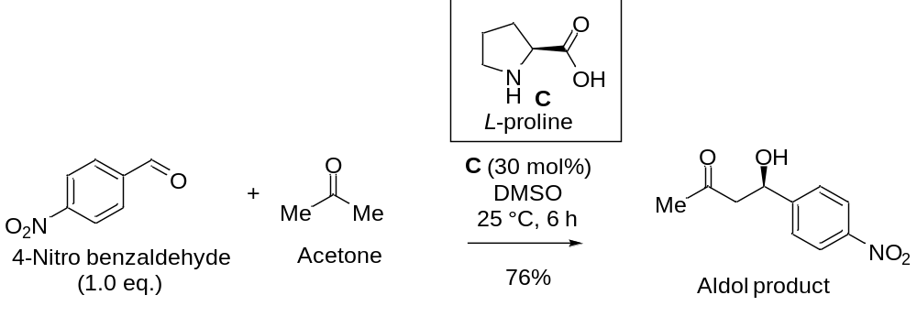
Apparatus Requirement:

Round Bottom (RB) flask; Magnetic bid; Magnetic stirrer; Measuring cylinder.

Chemicals Requirement:

- L-proline
(enantiopure - commercially available)
- Acetone
- Dimethyl sulfoxide (DMSO)
- P-Nitrobenzaldehyde

Calculations:

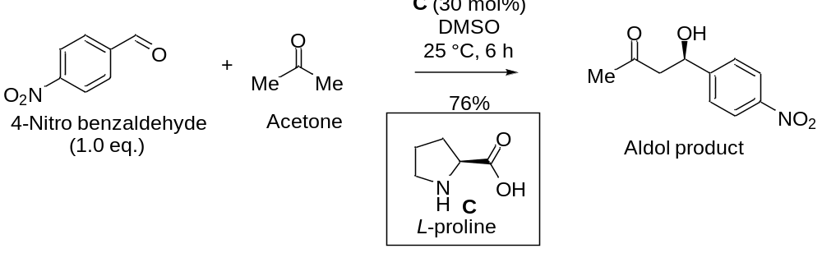

equiv.: 1.0 eq. - 0.3 eq.
mmol: 1 - 0.3 1
MW: 151.12 58.08 115.13 209.20
density: NA 0.784 g/mL NA NA
----------------------------------------------------------------------------------------------------------------
Amount: 151 mg 35 mg 209 mg
(Theoretical Yield)

Solvents: Acetone: DMSO = 1 mL: 4 mL

Acetone used a reagent as well as solvent.

Experimental Procedure for L-Proline Catalyzed Aldol Reaction:

In a round-bottom flask fitted with a stirrer, 35 mg (0.3 mmol, 0.3 equiv.) of L-proline was taken in acetone and DMSO mixture (1 mL of Acetone and 4 mL of DMSO was added).

Then the RB flask was placed on an ice-bath having temperature at 0 °C. Next, 151 mg of solid p-nitrobenzaldehyde (1 mmol, 1.0 equiv.) was added slowly to the reaction mixture and stirring was continued for additional 15 minutes at 0 °C.

Next, the round-bottom flask was allowed to warm slowly to 25 °C. The stirring was continued for another 6-7 h at room temperature.

Upon completion of the reaction [as judged by running TLC (Thin Layer Chromatography)], water was added to it (5 mL) and it was extracted with ethyl acetate (5 mL X 2). Then, all the organic layers were collected and dried over sodium sulfate and were evaporated under reduced pressure to furnished crude Aldol product.

The crude product was purified under column chromatography using petroleum ether and ethyl acetate as eluents.

The enantioselectivity of this Aldol product was done by using HPLC on a chiral phase Chiralpak IC-3 column. The racemic product of this reaction was made by racemic proline using the same procedure as described above.
------------------------------------------------------------------------------------------------------------------------

Results & Observation:

Actual Yield: 158 mg % of Yield: (Actual Yield / Theoretical Yield) × 100

Theoretical Yield: 209 mg = (158/209) × 100

= 76%

Physical State: Yellow gel

Specific Rotation: + 35.5 ° (c=0.2, CHCl₃) for 73% ee.

TLC System: R_{f} = 0.3 (30% EtOAc in n-hexane)

IR Frequencies: 3512, 2923, 2454, 1706, 1602, 1173, 1071 cm⁻¹

------------------------------------------------------------------------------------------------------------------------ Characterization of Aldol Product:

The final product was characterized by IR spectra, ¹H NMR spectra, ¹³C NMR spectra, and HRMS spectroscopy.

Characterization using NMR Techniques:

¹H NMR (500 MHz, CDCl₃) δ 8.23 (d, J = 8.7 Hz, 2H), 7.56 (d, J = 8.7 Hz, 2H), 5.28 (dt, J = 7.4, 3.5 Hz, 1H), 3.63 (d, J = 3.3 Hz, 1H), 2.96 – 2.76 (m, 2H), 2.24 (s, 3H).

¹³C NMR (126 MHz, CDCl₃) δ 208.5, 150.0, 147.4, 126.4, 123.8, 68.9, 51.5, 30.7.

HPLC Analysis: 73 % ee (by HPLC on a chiral phase chiralpak IC-3 column, λ = 254 nm, ^{i}PrOH/hexane = 05:95, 22 °C, 1 mL/min; t_{R} = 26.62 min (minor), 28.32 min (major)).

------------------------------------------------------------------------------------------------------------------------

Conclusion:

In summary, we have carried out L-proline catalyzed enantioselective Aldol reaction of acetone with p-nitrobenzaldehyde. The chemical yield was 76% (isolated yield of pure compound after column chromatography). The Aldol product was characterised by IR spectra, NMR spectra as well as Specific rotation was measured in a polarimeter.

The mechanism of this reaction should be taken as home assignment.

